**Why is the wave function complex-valued?**

**Part 1: the Wave-Function (w.f.)**

In Quantum Mechanics (Q.M.), the wave function (denoted by the Greek letter, Ψ) is a mathematical function describing the probability density of a particle at a particular point in space and time; it therefore provides a mathematical framework behind the behaviour of a quantum system, such as: an atom, molecule, or particle. In the case of non-relativistic Q.M., this is usually represented by a complex-valued function, composed of real and imaginary parts. On the contrary, in Classical Physics, the behaviour of a physical system is governed by Newton’s laws of motion, which state that an object’s position (**x**), velocity (**v**), and acceleration (**a**) can be precisely calculated at any given time. And yet, in Q.M., we know that the behaviour of a physical system isn’t straightforward and cannot be precisely determined. Instead, the behaviour of a quantum system can be described using probabilities (thus, cue the Statisticsy Maths-type *stuff*).

The magnitude of the wave function (w.f.) at a particular point in space is known as the probability density. This probability (often referred to as p(**x**)) for finding a particle within a certain region of space is equal to the integral of the probability density over that region, given by **Equation 1**.

p(**x**) = Ψ(**x**, t) Ψ*(**x**, t)

**Equation 1:** the probability of find a particle, x, at time, t, given a normalised w.f.

whereby we stipulate the following statement, given by **Equation 2**.

$\int_{C.S.}{Ψ_{C.S.}(x, t)Ψ_{C.S.}^{∗} (x, t)}$ d**x** = 1

**Equation 2:** the total probability over the entire *configuration space* (C.S.), e.g. *dx.dy.dz*, of all points acted upon by the normalised w.f., which is denoted by the italicisation of Ψ.

As a result of **Equation 2**, we are therefore able to write that $\int_{C.S.}{{|Ψ(x,t)|}^{2}}$ d**x =** 1 [1], which is also known as *the normalisation condition* for the w.f. specified. For instance, in **Equation 3** to describe the normalised[2] w.f. of what is referred to as a Gaussian[3] *“wave packet”*, centered at x = x0, we have:



**Equation 3:** the normalised w.f. of a Gaussian *wave packet* centered at x = x0.

However, we first require the *normalisation constant* given by *ψ0*, for which we substitute **Equation** **3** into **Equation 2**. By then changing the *variable of integration* to y = $\frac{x − x_{0}}{\sqrt{2}σ}$, we arrive at:

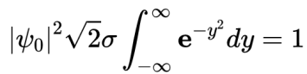

**Equation 4:** the *normalisation constant* inserted into *Equation 3*.

We are able to split **Equation 5** into two sections: the *normalisation factors*, and the integrand over the entire C.S. which we specified back in **Equation 2**. Evidently, the latter is an example of a Gaussian integral:

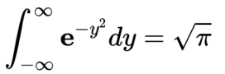

**Equation 5:** the standard integral for the Gaussian function, with coefficient: a = 1.

By rearranging **Equation 5** for the magnitude squared term[4] for *ψ0* **∈**ℂ, we find in **Equation 6** that:

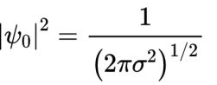

**Equation 6:** the magnitude squared of the *normalisation constant*, found by rearrangement of *Equation 4* with *Equation 5* inserted*.*

Putting all this together, a general, normalised, Gaussian[5] w.f. is found in **Equation 7**:

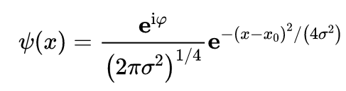

**Equation 7:** the form of a generalised, normalised, Gaussian w.f*.,* with μ = x0, σ = , and φ is an arbitrary real phase-angle. **N.B.** the Gaussian distribution itself has values of μ = x0, σ² = h²/4σ².

It is now of relevance to demonstrate the permenance of the normalisation of this w.f. as it evolves w.r.t. time in accordance with the Schrödinger Equation[6]. Were this not to be the case, then our *probability interpretation* of the w.f. is unfounded; it would not make sense for p(x) to yield any possible outcome which changes in time, when it is conspiciously of unitary value. Therefore, in **Equation 8**, we require:

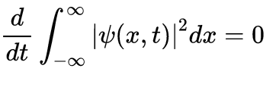

**Equation 8:** the following statement holds for all w.f.ssatisfying the Schrödinger Equation.

From **Equation 8**, unpacking the *conjugate pair* of **Equation 2**, we yield **Equation 9**:

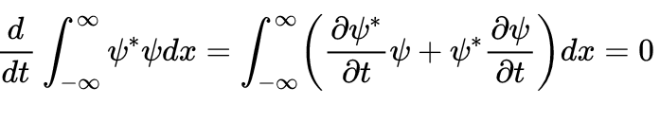

**Equation 9:** the expanded form of the Schrödinger Equation condition stipulated by *Equation 8*.

If we multiply through the Schrödinger Equation by $\frac{ψ^{x}}{iℏ}$, we obtain **Equation 10**:

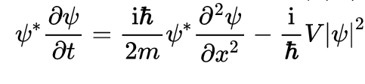

**Equation 10:** the Schrödinger Equation multiplied by $\frac{ψ^{x}}{iℏ}$.

The complex conjugate of **Equation 10** results in **Equation 11**:

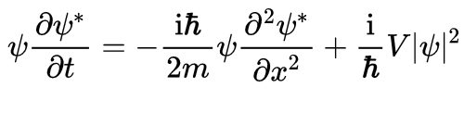

**Equation 11:** the complex conjugate of *Equation 10*, due to (**A** **B**)* = **A**\* **B**\*, **A**\*\* = **A**, and **i**\* = **-i**.

We combine **Equation 8** with **Equation 11** to yield **Equation 12**[7]:



**Equation 12:** the combined integrands of *Equation 8* and *Equation 11*, given $|Ψ(x,t)|$ → 0, as $|x|$ → ∞.

Observe that these are necessary conditions in the caption of **Equation 12** in order that the L.H.S. of the *normalisation condition* converges. We can therefore conclude, for all *square-integrable* *w.f.s*, they have the universalisation property that if the condition is satisified at one instance in time, it is satisfied ∀ t **∈**ℝ. It is therefore also possible to show, by similar method, the following in **Equation 13**:

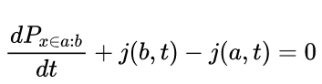

**Equation 13:** where Px**∈**a: b is defined by $P_{x ∈ a : b}= \int_{a}^{b}{{|Ψ(x,t)|}^{2}}$ dx, s.t. a < b, It is a *probability conservation equation*.

and we apply the further condition of **Equation 13** in **Equation 14** that:

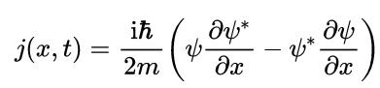

**Equation 14:** the following is a condition of *Equation 13*, where j**∈**ℝ. It is referred to as the *probability current*.

According to **Equation 14**, the probability of a measurement in x located within the interval [a,b] evolves in time, on account of the difference between the flux of probability into the interval, i.e. *j(a, t)*, and that going out of the interval, i.e. *j(b, t)*. We interpret *j(x, t)* as a flux of probability, at time *t* and position *x* in the direction of +x. As not all w.f.sare normalisable using the *normalisation condition* of a w.f., we note, for instance, the lack of *square-integrability*, and thus normalisability of the plane wave’s w.f. in **Equation 15**.

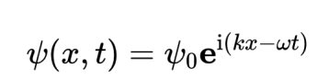

**Equation 15:** a plane wave’s w.f., which is *unnormalisable (see Equation 2)*  due to its lack of *square-integrability*.

It is best practice for these w.f.s to follow the following proportionality relation in **Equation 16**:

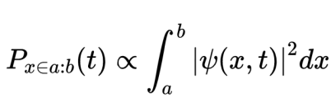

**Equation 16:** unless otherwise stated, all w.f.s are *normalised*, and *square-integrable*.

The time-evolved, *Gaussian wave packet* is shown below by **Figure 1**.

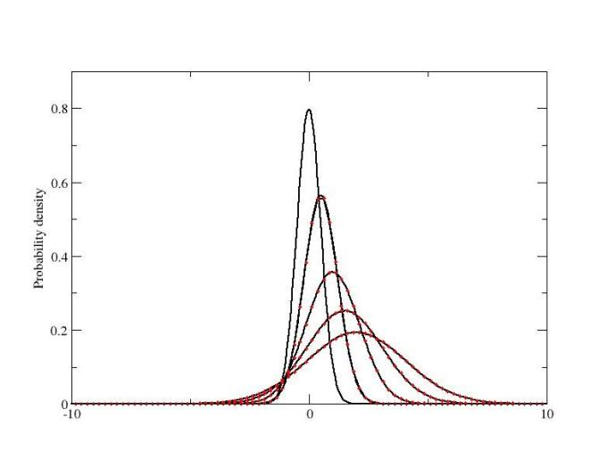

**Figure 1:** the Gaussian wave packet, with snapshots every 500 time steps for dt = 0.0001. The conditions are: σ = 1, x₀= 1.

The following is an example of a probability conservation equation, such as the one employed in **Equation 13** whereby the area under the curve is conserved. In **Equation 13**, this is defined between a and b, for a < b.

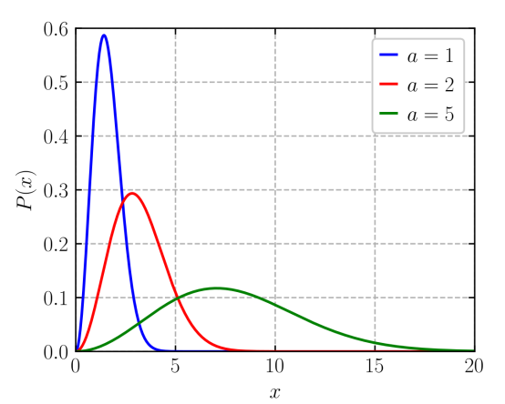

**Figure 2:** the Maxwell-Boltzmann distribution, an example of probability conservation.

Besides the evaluation of the Schrödinger Equation and the w.f., one of the key principles of Q.M. is the *Heisenberg Uncertainty Principle*, which states the impossibility of precise determination in both the position (**x**) and momentum (**p**) of a particle simultaenously. This uncertainty is reflected by the w.f., which is spread out over time and space, rather than concentrating at a singular point. In terms of practical applications, the w.f. is also an important concept in the development of quantum computers, which employ quantum bits *(qubits)* to store and process information. Qubits are founded upon the principles of Q.M., such as the w.f., and are able to perform certain calculations much faster than classical computers.

**Part 2: Why the w.f. is complex-valued (ψ∈ℂ)**

A reason for the w.f. being complex-valued is it allows for the description of the behaviour of particles which can take on wave-like and particle-like properties, such as photons and electrons. This *wave-particle duality* enables for the exhibition of both wave-like interference patterns, as well as particle-like behaviours, e.g. *being detected at specific locations*. This use of the complex-valued w.f. enables for the description of both amplitude and phase of the wave, which are important for understanding the behaviour of these particles, as well as in the Schrödinger Equation; this describes the time evolution of the w.f., and enables predictions about the behaviour of Quantum systems. Since the wave function is a solution to the *Schrödinger Equation* (S.E.), which is a differential equation denoting time evolution of the wave function, for the w.f. to satisfy this equation, it must also be complex-valued since the S.E. involves such numbers. In all, the use of complex numbers in Q.M. enables a more complete, and accurate description of the behaviour of Quantum systems.

It also allows for the representation of phenomena, e.g. *quantum superposition*[8] *and entanglement*[9], which cannot be explained by real numbers. *Superposition* is a phenomenon in which a Quantum system can exist in multiple states simultaneously. It is a fundamental concept in Q.M. and is difficult to understand using Classical concepts. By contrast, in Classical Mechanics, a system can only be in one state at any given time. For instance, a ball can either be rolling on the ground, or in the air, but never in both states at the same time. However, in Q.M., a Quantum system can be in multiple states at the same time, as long as the states are not mutually exclusive. An example of this is that a quantum particle can be in multiple positions at the same time, due to the fact that the w.f. of a Quantum system can be a *superposition* of multiple w.f.s, each corresponding to a different state of the system. The use of complex numbers in the w.f. therefore allows us to represent this *superposition* of states precisely. From **Equation 2**, the probability of finding the system in a particular state is given by the square of the w.f. at that state, whilst the probability of finding the system in a *superposition* of states is given by the sum of the squares of the w.f. for each state.

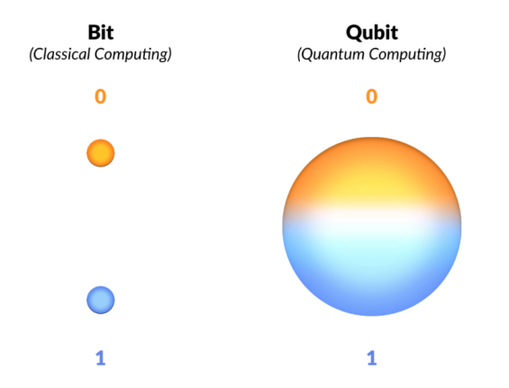

**Figure 3:** the difference between a Quantum *Qubit*, and a Classical *Bit*.

*Entanglement* is a phenomenon that occurs when two or more Quantum systems become correlated in a way that cannot be explained by Classical Physics. It is a form of *Quantum correlation* stronger than any classical correlation. The w.f. can represent *entanglement* by the following: imagine two Quantum systems, A and B, that are *entangled*. The w.f. for the combined system *(A and B)*, can be written as a product of the w.f.s for each individual system: Ψ(Α, Β) = Ψ(Α) × Ψ(B). This means that the w.f. for the combined system is a combination of the w.f.s for each individual system. However, if the two systems are *entangled*, the w.f. for the combined system cannot be written as a simple product of w.f.s for each individual system. It instead must be written as a more complex function that takes into account the *entanglement* between two systems. For instance, if the two systems are *entangled* in such a way that measuring the *spin* of one system affects the *spin* of the other system, then the combined system’s w.f. must include information about this entanglement. Thus, the w.f. is a powerful tool for understanding and predicting the behaviour of Quantum systems that exhibit *entanglement*: complex numbers allow for this representation.

**Part 3: Philosophical Implications of Q.M., and Superposition**

Throughout the development of Q.M., various interpretations have been formulated attempting to link Q.M. with our perceived reality. Weltanschaaungs are held on, for example, whether it is stochastic or deterministic, which elements may be labelled real, and the nature of the measurement itself. Despite this, the Sisyphean struggle has yield no superior interpretation to best describe reality.

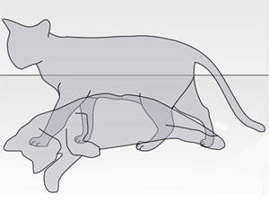

**Figure 4:** the Copenhagen Interpretation gives rise to the paradox of Schrödinger’s Cat.

The Copenhagen Interpretation (1925) was devised by Schrödinger who contrived the eponymously-named thought experiment, Schrödinger’s Cat, as an attempted rebuke of the rigidity of w.f. collapse. In an act of absolute genius, we have collectively decided to distill this macabre *memento mori* into the popular conscience, by relating a cautionary tale of placing a cat into a box *(containing a flask of poison)*, whereupon opening the box reveals a cat found dead or alive, with a 50-50 chance of either occurring; John Gribbin[a] went as far as to deride this as *quantum cookery*, whilst Veritasium’s Derek Muller posited many-worlds as the favoured interpretation. In my application to University, I myself referred to the interpretation as *bludgeoned to fit experimental observations in a feat of epistemological gastronomy*: cringe-worthy hyperbole which I now have to revisit in the midst of a rather-stubborn migraine. And yet in spite of this, so perfect are the tools which Copenhagen provides us with, so magnificent are the observations and correspondences with Classical Physics, and so fantastical are the properties of its systems that we can’t help but proverbially gaslight more cogent theories such as the Everettian interpretation, in favour of debauched flirtations with perfect probabilities and sexy graphs. Nevertheless, the unchanging relevance of Copenhagen is a testament to its utility in everyday calculations.



**Figure 5:** the Many-Worlds Interpretation of Quantum Mechanics.[A]

The Many-Worlds Interpretation (1957) was formulated by Hugh Everett as his PhD thesis[b], hoping to put an end, once and for all, to the exisential confusion brought upon Physics by the Copenhagen interpretation. The proposed means of resolving this is to consider each different state following a w.f. collapse as an entirely-new branch of reality. This means we can eliminate various paradoxoi, e.g. Schrödinger’s cat, EPR paradox, Wigner’s friend, the double slit experiment, and von Neumann’s *boundary problem,* etc. Due to the insistence on the existence of a Classical domain which is beyond the description provided by Q.M., Many-Worlds is often singled out for its lacking discussion on cosmology. Furthermore, it is a deterministic, local, and realist theory through the removal of the w.f. collapse, which is non-local and indeterministic. Despite this, it still provides context for the anthropic principle *(*search *fine-tuned universe)*, and crucially, MWI depends on the linearity of Q.M., which underlies the *superposition principle*. All quantum field theories are not only linear, but therefore compatible with MWI, with the notable exceptions of gravity and string theory.

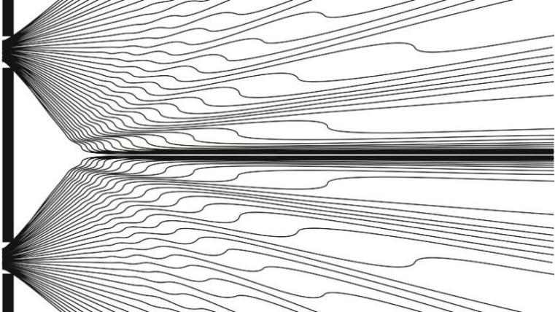

**Figure 5:** the Bohmian Interpretation of Quantum Mechanics.

Bohmian Mechanics (1927), sometimes referred to by its predecessor, Pilot Wave Theory, was first presented at the 1927 Solvay Conference[c], well-known for its star-studded photograph featuring Physics juggernauts such as Albert Einstein, Marie Curie, Paul Dirac, Wolfgang Pauli, Niels Bohr, Max Born, Werner Heisenberg, Erwin Schrödinger, and of course, Max Planck. It was at this conference, in close collaboration with Schrödinger, that de Broglie worked on this nascent theory. However, it wasn’t before long before Pauli had pointed out its incompatibility with the semi-Classical technique put forward by Pauli in the case of inelastic scattering. Whilst de Broglie succeeded in delivering a well-mannered rebuttal, it wasn’t long before he abandoned the theory, leaving the baton to be carried by David Bohm at Princeton in his paper: *A Suggested Interpretation of the Quantum Theory in Terms of “Hidden” Variables I & II* (1952), which was well received by Einstein. It wasn’t enough to stave off criticism, however, as whilst it makes more physical intuitive sense, it adds a guiding equation, global hidden variables, and is wholly incompatible with special relativity and Quantum Field Theory (it requires the removal of the *non-locality* condition).

Having considered these three differing interpretations of Q.M., each having to tolerate at least some degree of weirdness, as well as casting aside intuition, we continue our exploration of the Quantum realm through the phenomenon of *Quantum superposition*, sometimes referred to as the *Superposition Principle*. In the most straightforward of the three, the Copenhagen interpretation, we note the linearity of the SE, and proceed as one would expect Q.M. to. For instance, by considering an electron (e-), and its possible arrangements, we discover that it can be considered *spin “up”* or *“down”*, describing the physical system of an aforementioned *qubit*: gives the most general state, for instance. Coefficients are used to dictate the system’s probability of being in either configuration, which is given by the squared absolute value of the coefficient. Thus, we have **Equation 17**:

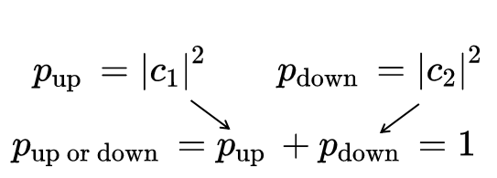

**Equation 17:** probabilities of a specific configuration, given by the squared absolute-value of the coefficient, adding to 1. This makes the two states mutually-exclusive, since the electron ought to be in one of the two states.

Conversely, from Assessed Problem Set 2, we are able to determine the probability of either state for a particle which can be in an *up-state* or *down-state*, as shown by **Equation 18**:

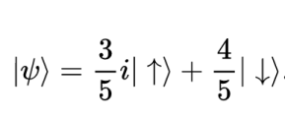

**Equation 18:** probabilities of a specific configuration, where there exists an amount ⅗ **i**for *up*, and ⅘ for *down*. Consequently, this results in $|$ ⅗ ${| }^{2}$ = $\frac{9}{25}$, $| ⅘ {| }^{2}$ = $\frac{16}{25}$, which evidently sums up to 1. Note that there can be ∞-tely many configurations.

Thus, we have been guaranteed that there exist states which are arbitrary superpositions of all these positions which have coefficients *ψ(x)***∈**ℂ. We only define this sum for discrete values of the index, *x*. Instead replacing the coefficients with *ψ(x)***∈**ℝ, we find that this new sum turns into an integral as we tend towards infinity, and this quantity *ψ(x)* is now the w.f. of a particle! We have come the full circle.

### References

References have been compiled in the IEEE format.

**Books & Journals**

[a] Gribbin, J.R. (2016) *In Search of Schrodinger's Cat: Quantum physics and Reality*. New York: Bantam Books.

[b] Everett, H.D. (1952) “The Many-Worlds Interpretation of Quantum Mechanics.”

[c] Bohm, D. (1952) “A suggested interpretation of the quantum theory in terms of ‘hidden’ variables. II,” *Physical Review*, 85(2), pp. 180–193. Available at: https://doi.org/10.1103/physrev.85.180.

**Websites**

[1] Prof. Dowker, F. (no date) *Quantum Mechanics - Chapter 1 to 5 Notes*, *Quantum Mechanics*. Available at: https://bb.imperial.ac.uk/webapps/blackboard/execute/content/file?cmd=view&content_id=_2724007_1&course_id=_33885_1&launch_in_new=true (Accessed: January 13, 2023), page 12.

[2] Prof. Dowker, F. (no date) *Quantum Mechanics - Chapter 1 to 5 Notes*, *Quantum Mechanics*. Available at: https://bb.imperial.ac.uk/webapps/blackboard/execute/content/file?cmd=view&content_id=_2724007_1&course_id=_33885_1&launch_in_new=true (Accessed: January 13, 2023), page 5.

[3] Prof. Dowker, F. (no date) *Quantum Mechanics - Chapter 1 to 5 Notes*, *Quantum Mechanics*. Available at: https://bb.imperial.ac.uk/webapps/blackboard/execute/content/file?cmd=view&content_id=_2724007_1&course_id=_33885_1&launch_in_new=true (Accessed: January 13, 2023), page 64-66.

[4] Prof. Dowker, F. (no date) *Quantum Mechanics - Chapter 1 to 5 Notes*, *Quantum Mechanics*. Available at: https://bb.imperial.ac.uk/webapps/blackboard/execute/content/file?cmd=view&content_id=_2724007_1&course_id=_33885_1&launch_in_new=true (Accessed: January 13, 2023), page 65.

[5] Prof. Dowker, F. (no date) *Quantum Mechanics - Chapter 1 to 5 Notes*, *Quantum Mechanics*. Available at: https://bb.imperial.ac.uk/webapps/blackboard/execute/content/file?cmd=view&content_id=_2724007_1&course_id=_33885_1&launch_in_new=true (Accessed: January 13, 2023), page 66.

[6] Prof. Dowker, F. (no date) *Quantum Mechanics - Chapter 1 to 5 Notes*, *Quantum Mechanics*. Available at: https://bb.imperial.ac.uk/webapps/blackboard/execute/content/file?cmd=view&content_id=_2724007_1&course_id=_33885_1&launch_in_new=true (Accessed: January 13, 2023), page 6.

[7] Prof. Dowker, F. (no date) *Quantum Mechanics - Chapter 1 to 5 Notes*, *Quantum Mechanics*. Available at: https://bb.imperial.ac.uk/webapps/blackboard/execute/content/file?cmd=view&content_id=_2724007_1&course_id=_33885_1&launch_in_new=true (Accessed: January 13, 2023), page 13.

[8] Prof. Dowker, F. (no date) *Quantum Mechanics - Chapter 1 to 5 Notes*, *Quantum Mechanics*. Available at: https://bb.imperial.ac.uk/webapps/blackboard/execute/content/file?cmd=view&content_id=_2724007_1&course_id=_33885_1&launch_in_new=true (Accessed: January 13, 2023), page 17.

[9] Prof. Dowker, F. (no date) *Quantum Mechanics - Chapter 1 to 5 Notes*, *Quantum Mechanics*. Available at: https://bb.imperial.ac.uk/webapps/blackboard/execute/content/file?cmd=view&content_id=_2724007_1&course_id=_33885_1&launch_in_new=true (Accessed: January 13, 2023), page 18.

**Media**

[A] Muller, D. (2020) *Parallel Worlds probably exist. here's why*, *YouTube*. YouTube. Available at: https://www.youtube.com/watch?v=kTXTPe3wahc (Accessed: January 13, 2023).